Product Sheet

PRO ANIMAL
PETS

6mm

INTENDED USE:
Absorbent pet litter. It is made of selected pine sawdust and offered in the form of granules. Bedding for cats, rabbits, guinea pigs, hamsters, ferrets, chinchillas, rats, mice

PRODUCT CHARACTERISTICS:
100% natural – made from pure, dry pine sawdust

Neutralizes odours and absorbs ammonia

Efficient – it effectively absorbs liquids by increasing its volume – up to 400% Hygienic and biodegradable - you can compost it once used
Prevents soreness

Safe – hypoallergenic – free of dust, bacteria, fungi and mould

Economical and easy to use – we replace only the clumped part of the bedding

PACKING METHOD:

15 kg bag
On a 1000mm x 1200mm pallet
65 bags – 975 kg
BIG BAG packing
weight from 1000 kg
At buyer's request pellet in BIG BAG
can be packed on a 1000mm x 1200mm pallet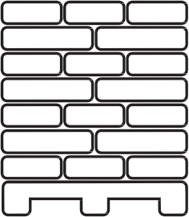
Bulk transport
up to 24 tonnes

Tipper

Movable floor and tarpaulin

Tanker

STORAGE:
Store in roofed, ventilated rooms, on a hardened concrete, or paved floor. The pellets in the Big Bags are stored on pallets.

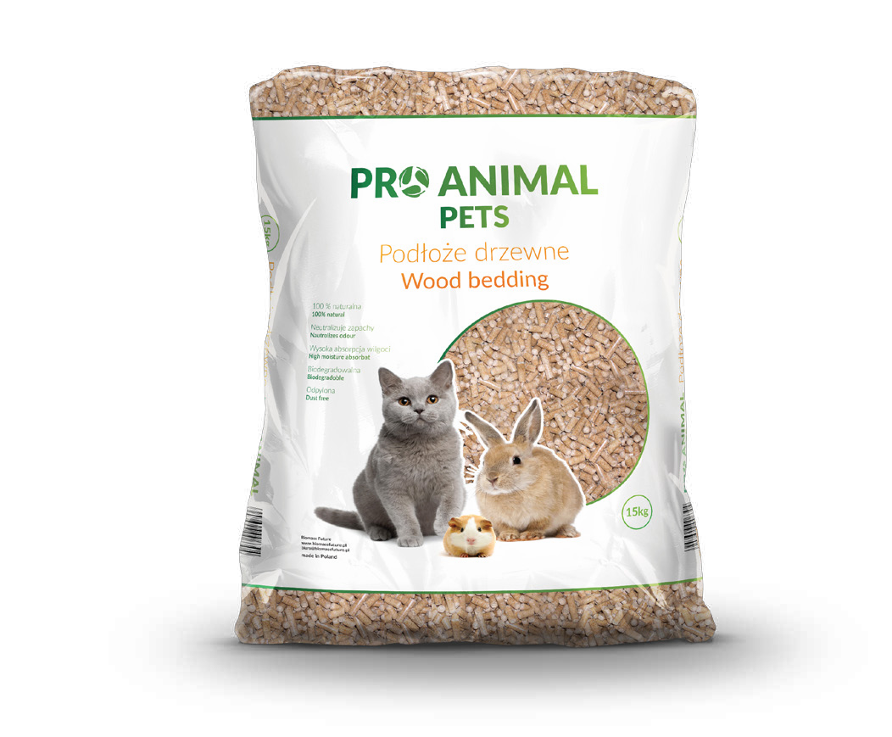www.biomassfuture.pl
biuro@biomassfuture.pl
+48 606 636 725
ul. Rozbitek 18/61, 64-420 Kwilcz

